|  |  |  |  |  |  |
| --- | --- | --- | --- | --- | --- |
| Date | 28-Nov-22 | | | Tester Name | Richard Belanger |
| Environment | Penfax - Test | | | Login used | Test 2 |
| Operating System | Windows | Version: | Update: | | |
| Software Used | Edge | Version: | Update: | | |
| Not Applicable | Version: | Update: | | |
| Release version | 22.4.1 | | | | |
| Title | M7.10 General 12 Month Member with other service types has low salary age <30 | | | | |
| Test Type | Regression | | | | |
| Test Scenario | Member will be Terminated and payment produced | | | | |
|  |  | | | | |
| Expected Results | Member will be Terminated and payment produced with correct taxes withheld | | | | |
| Pass/Fail | Pass | | | JIRA# | N/A |

Describe your steps with screenshots:

Member is a 12 month member, terminated October 14, 2022

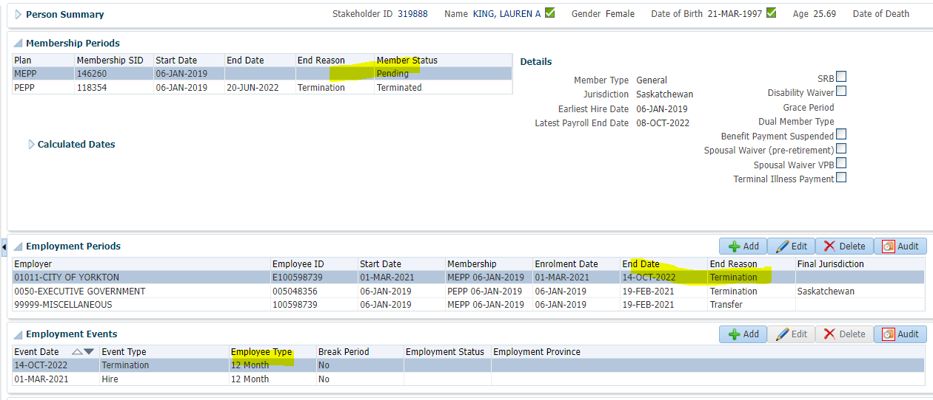

Member Profile>Benefit Calculation>Calculated>Processed

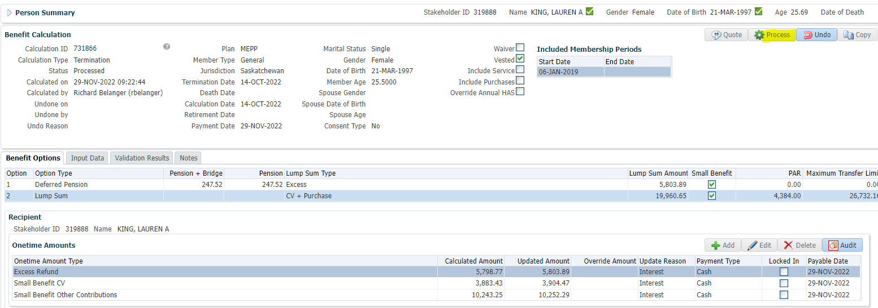

To Benefit Selection>Next

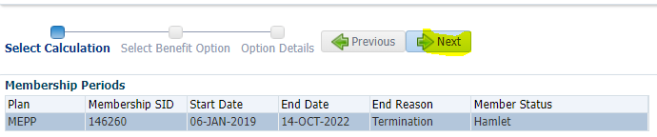

Choose Lump Sum line Add Payment Date>Next

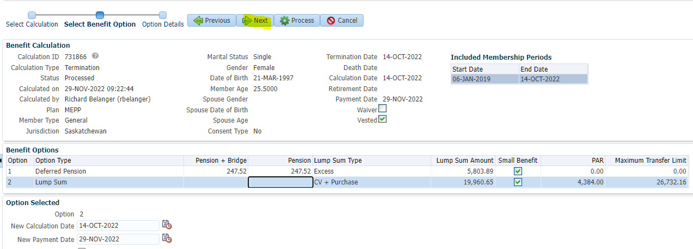

Process

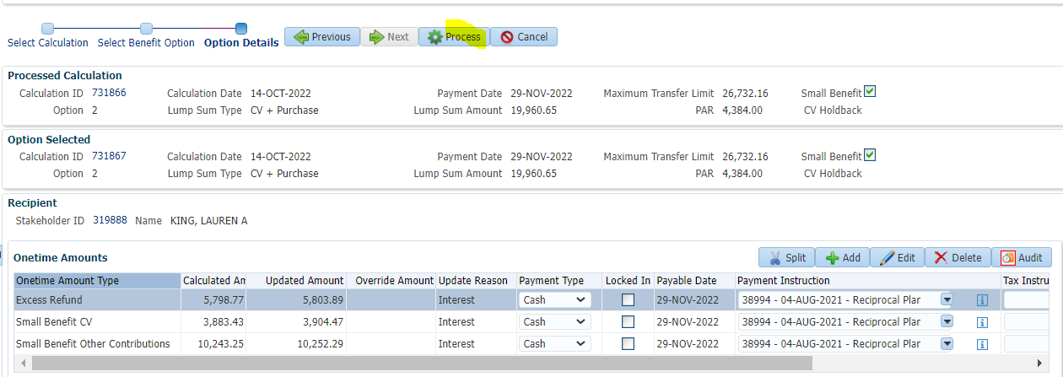

To Benefit Recipient>Submit the Payment lines for Approval>Approve>Authorize

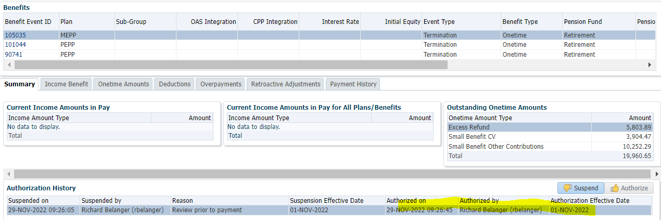

Payment processed via PENFAX Payment Production

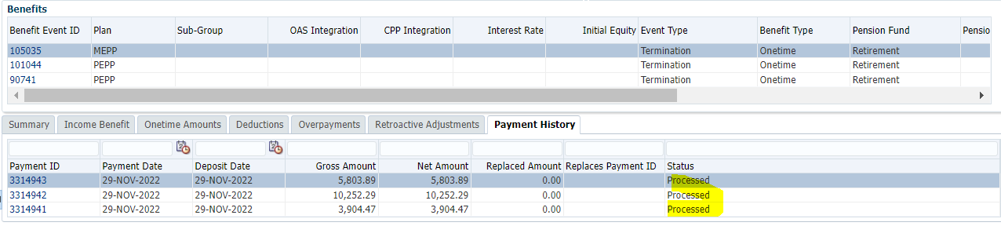

Tax Rates

0.00-4,999.99 = 10%

5,000.00- 14,999.99 = 20%

15,000.00+ = 30%